AUTOMATING THE BUILD AND DEPLOY

* **Export Powerbuilder’s json file:** Right click on the workspace>Export Build file>give the path>Export

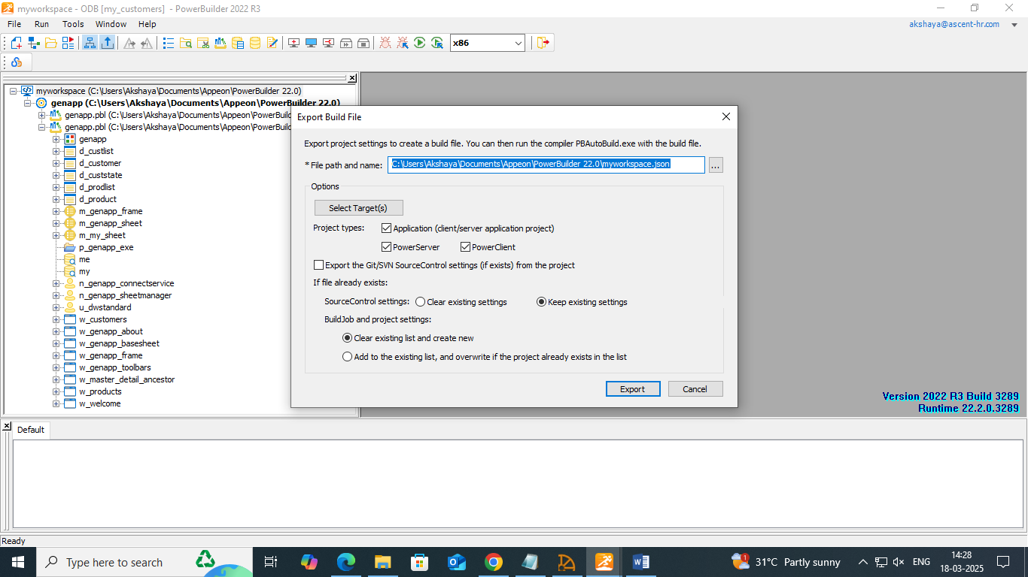

* **Check the json file in the given path:**

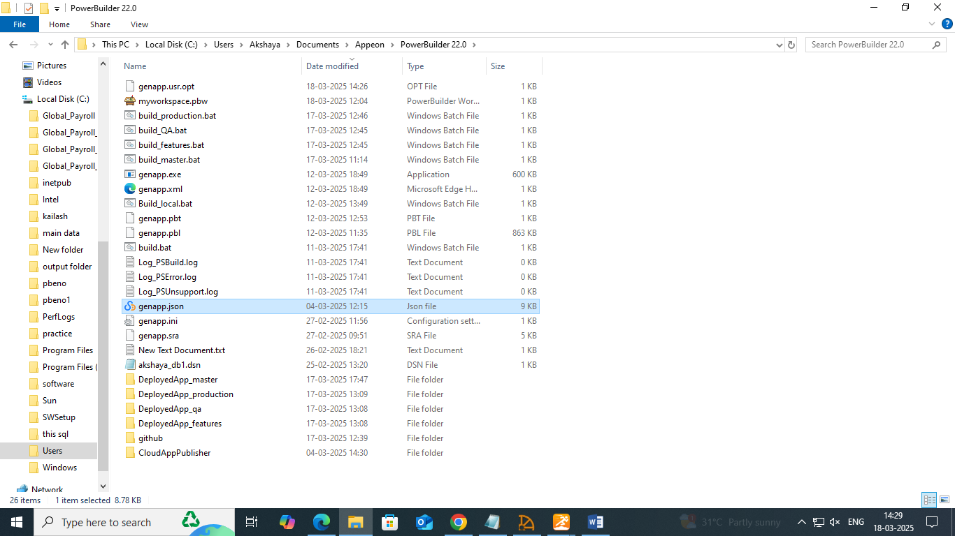

* Use PowerBuilder’s PBAutoBuild220.exe to automate builds. Install the PBAutoBuild220.exe from the Power Builder Installer.

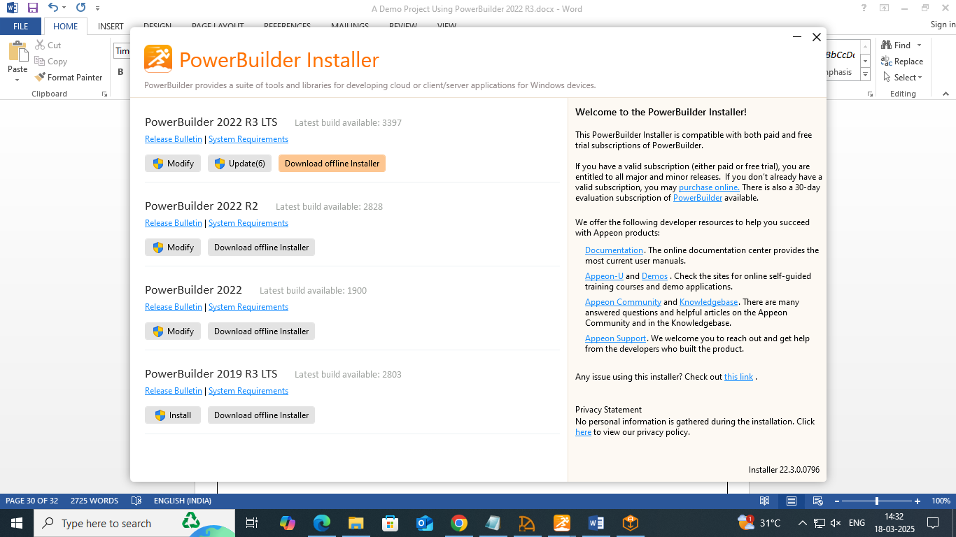

* 1. CREATE BRACHES SUCH AS MASTER, PRODUCTION, QA AND FEATURES WITH POWER BUILDER SOURCE CONTROL(USE GIT AND GITHUB)
* Create a new repository in the Github and push the code to master branch

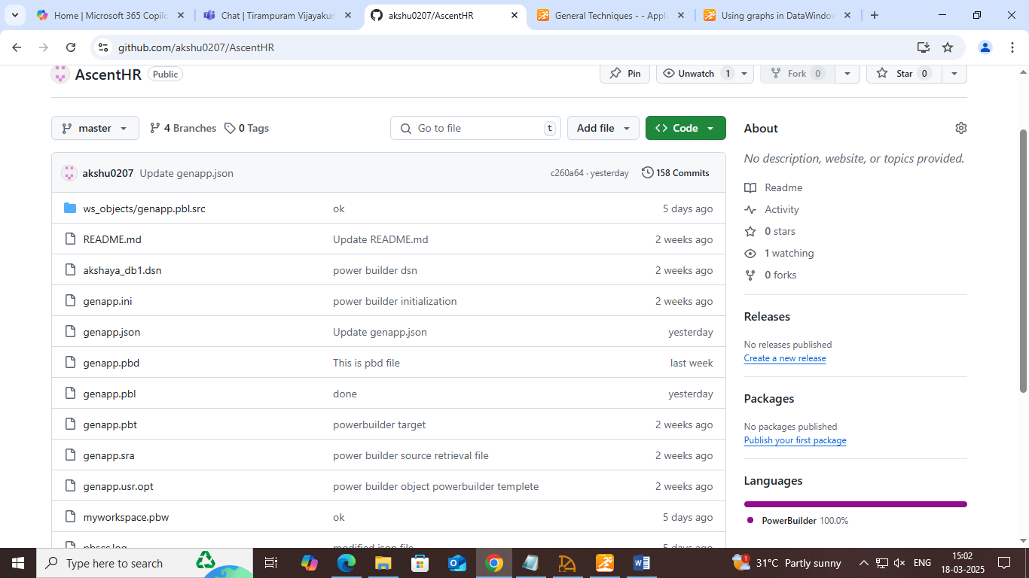

* Open PowerBuilder and navigate to workspace and right click and Source Control.
* Select Git as the source control provider.
* Configure the repository settings:
* Enter the Git Repository URL.
* Provide authentication details if required.
* Choose a local working directory.
* Click Connect to establish the link with Git.
* Use Check-in/Check-out options within PowerBuilder to manage code changes.

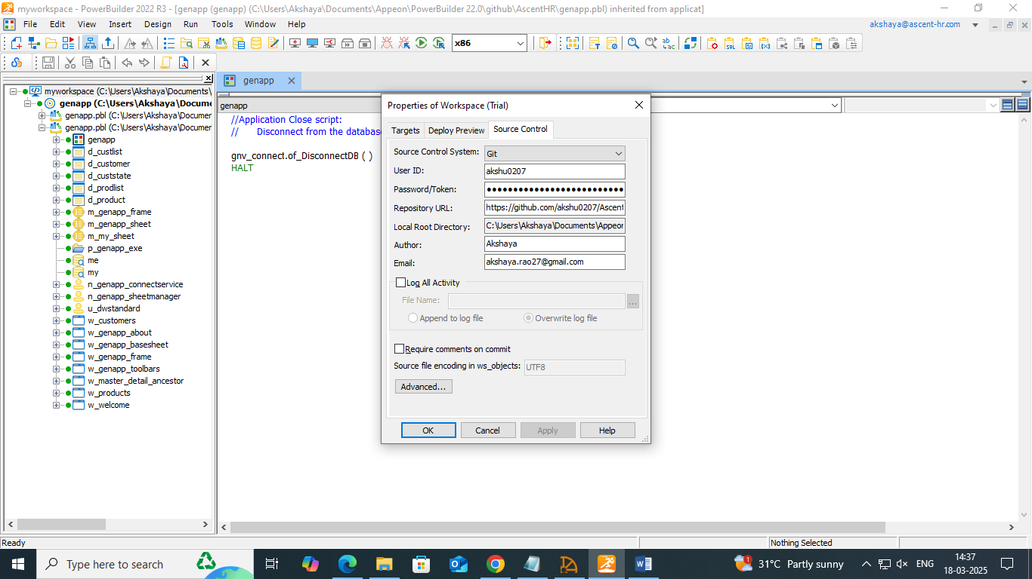

* Create new branch: right click on the workspace>create new branches.
* **Features:**

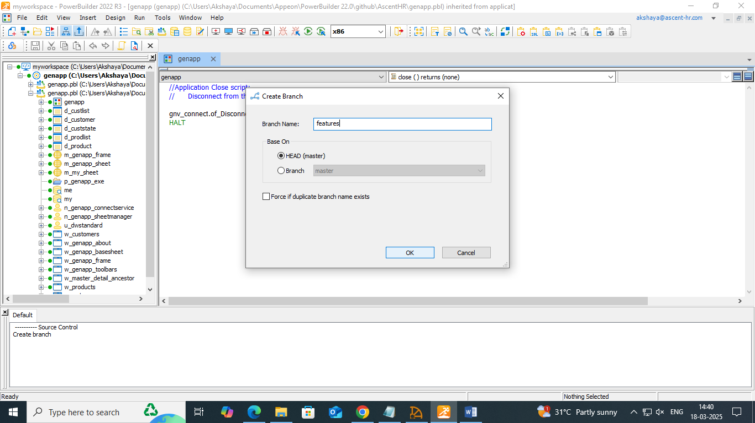

* **qa:**

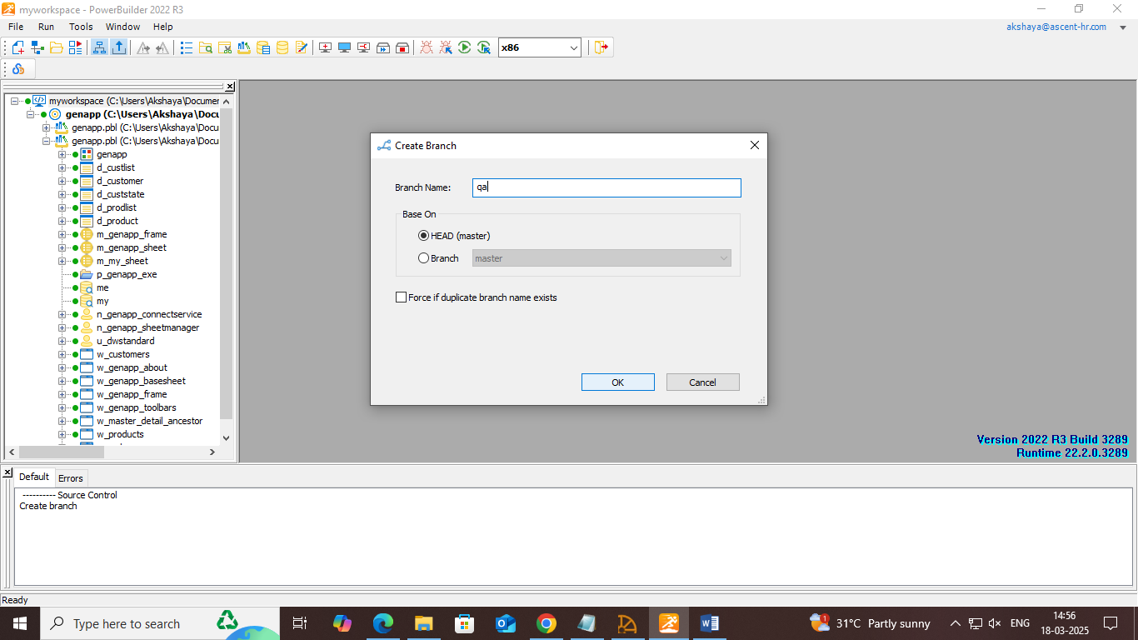

* **production:**

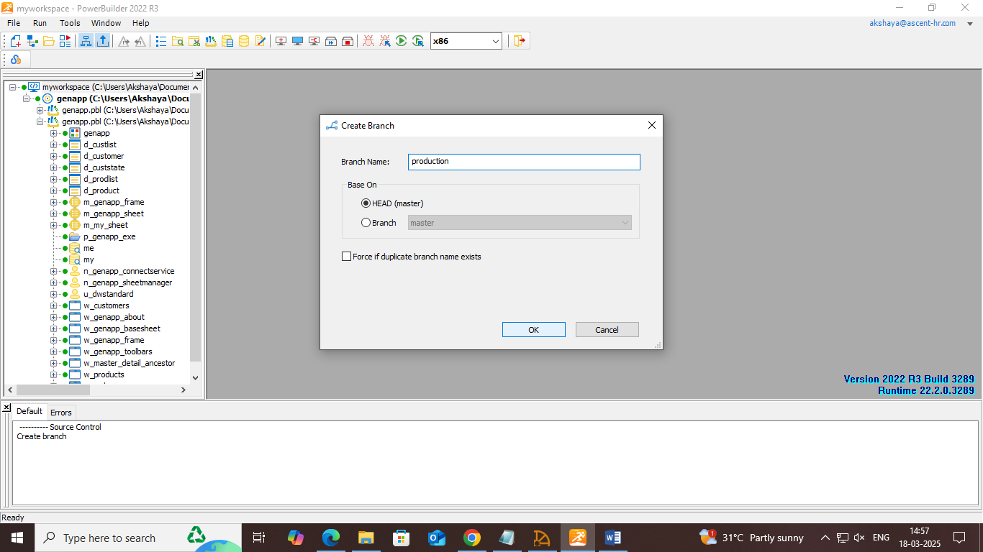

* **check the created branches in Github:**

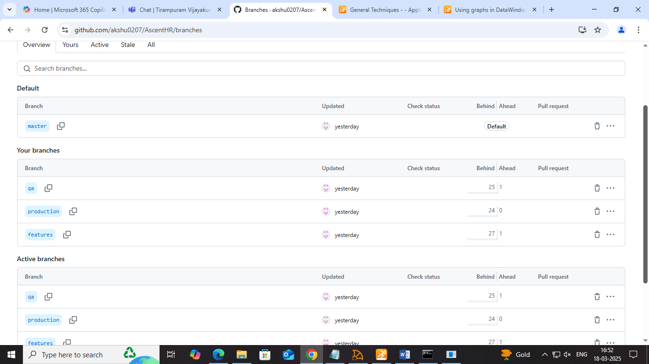

* **create a local repository in the same path as the PowerBuilder in the system:**

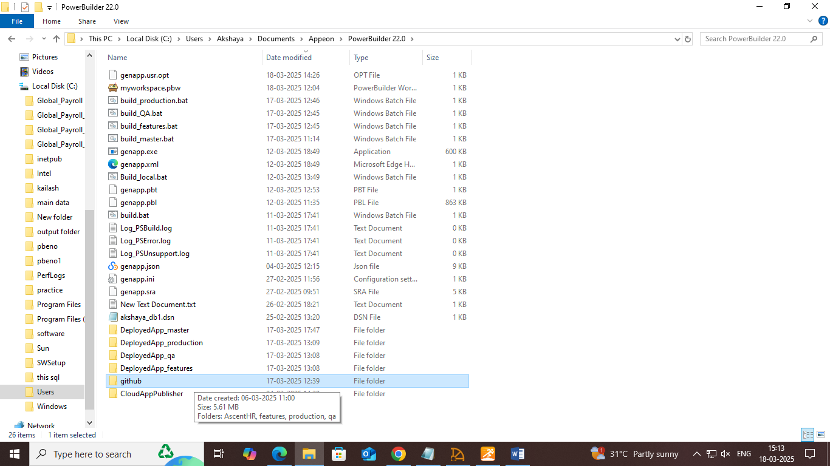

* **Clone into the repository as follows(use git/CMD):** copy the Repository URL as below:

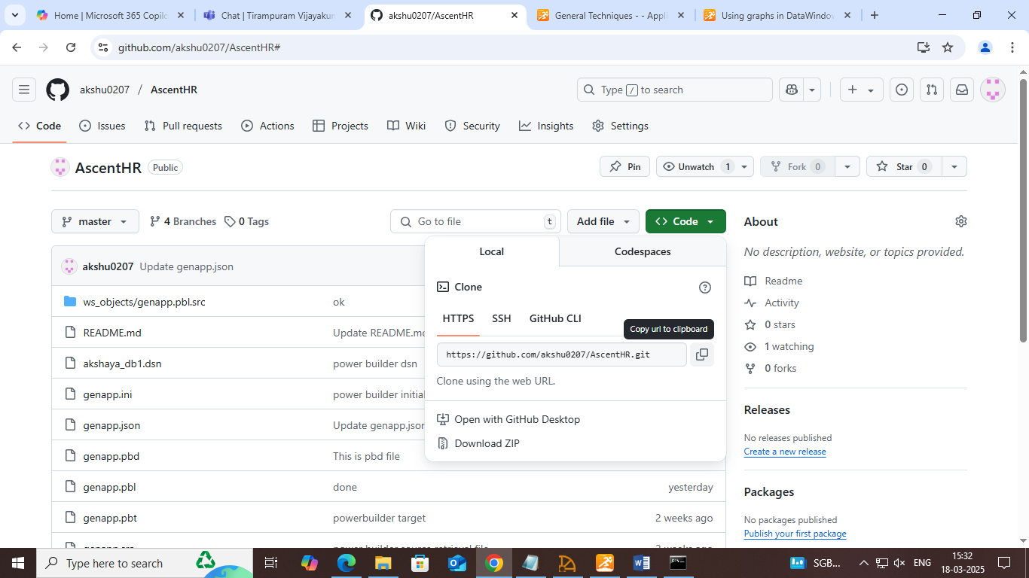

**Clone as follows:**

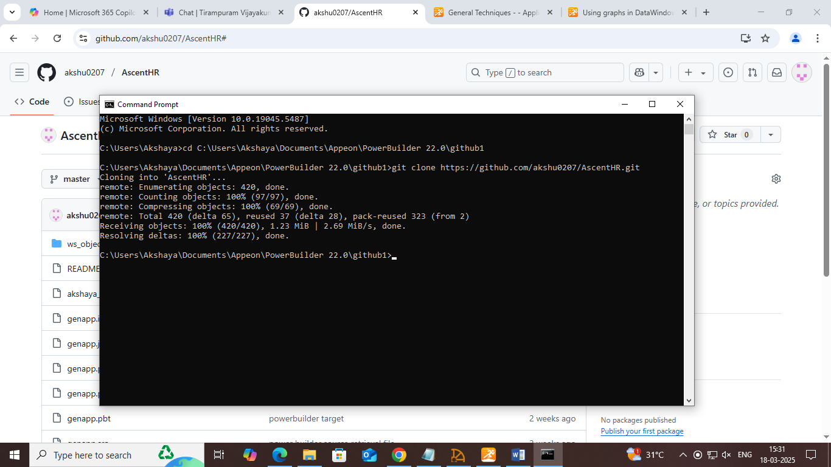

* For more organization and isolation of branch separate them into worktree using git (optional)

**$git worktree add ../features features**

**$git worktree add ../qa qa**

**$git worktree add ../production production**

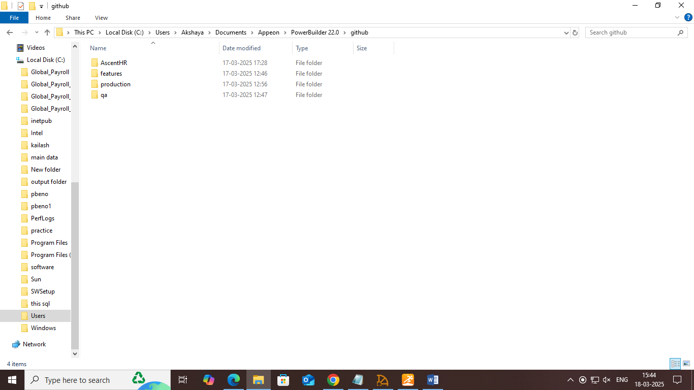

* Add new features to the application in the feature branch and merge it with QA branch and test the application with build script by pulling from the QA branch.

**Added new features and merged with qa**

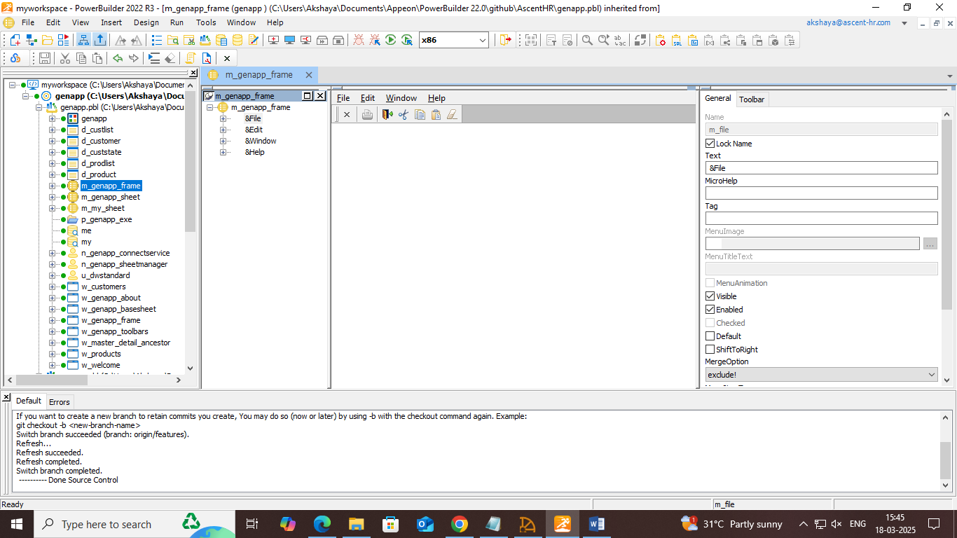

* **Commit the changes and push:** right click on the workspace>git commit>git push
* **Merge it with qa branch using git:**

**Switching the branch: $git checkout qa or right click on the workspace>switch**

**$git merge features**

* **Check qa branch**

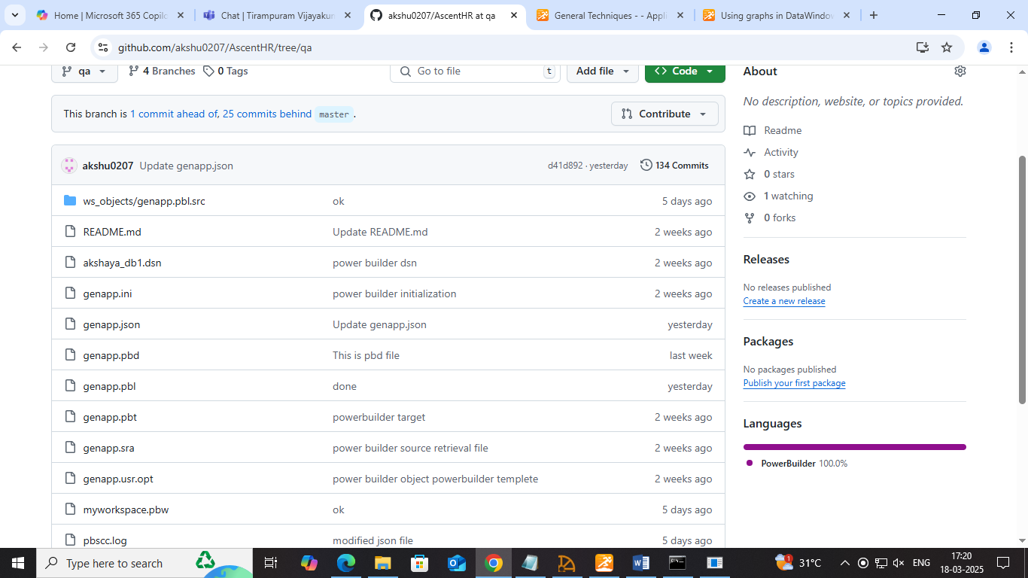

**Change the path of the Executable file in json to deploy the application in a different folder called DeployedApp_qa**

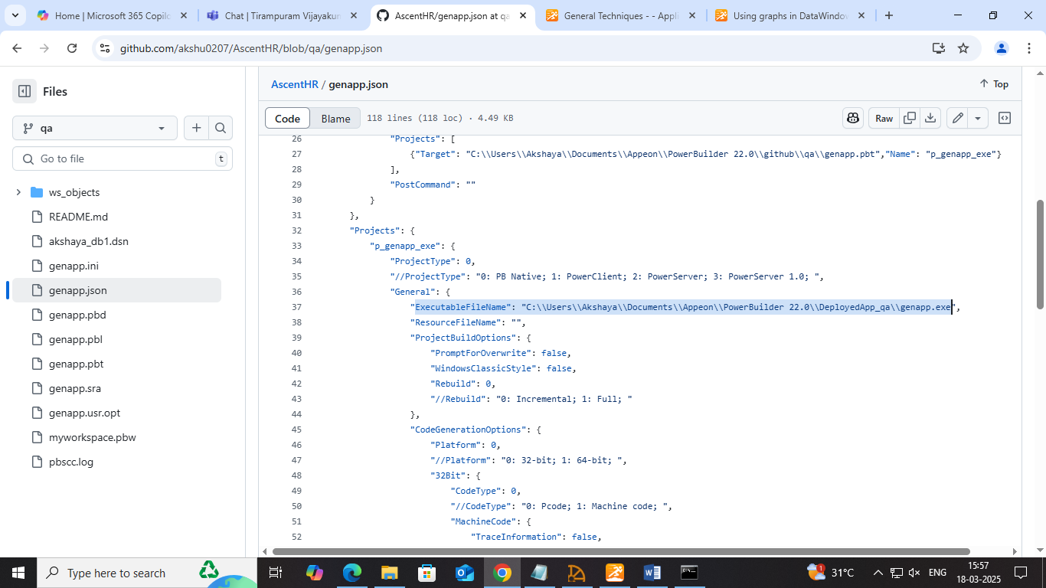

**Complete json:**

**﻿{**

**"MetaInfo": {**

**"IDEVersion": "220",**

**"RuntimeVersion": "22.2.0.3289"**

**},**

**"BuildPlan": {**

**"SourceControl": {**

**"PreCommand": "",**

**"ClearSrcBeforeDownload": false,**

**"SVN": [**

**{"SrcPath": "","User": "","Password": "","DestPath": "","Proxy": {"Ip": "","Port": 0,"Username": "","Password": ""}}**

**],**

**"Git": [**

**{"SrcPath": "","User": "","Password": "","DestPath": "","Branch": "","Proxy": {"Ip": "","Port": 0,"Username": "","Password": ""}}**

**],**

**"VSS": [**

**{"SrcPath": "","User": "","Password": "","DestPath": ""}**

**],**

**"Merging": [**

**{"Target": "","LocalProjectPath": "","RefreshPbl": true}**

**],**

**"PostCommand": ""**

**},**

**"BuildJob": {**

**"PreCommand": "",**

**"Projects": [**

**{"Target": "C:\\Users\\Akshaya\\Documents\\Appeon\\PowerBuilder 22.0\\github\\qa\\genapp.pbt","Name": "p_genapp_exe"}**

**],**

**"PostCommand": ""**

**}**

**},**

**"Projects": {**

**"p_genapp_exe": {**

**"ProjectType": 0,**

**"//ProjectType": "0: PB Native; 1: PowerClient; 2: PowerServer; 3: PowerServer 1.0; ",**

**"General": {**

**"ExecutableFileName": "C:\\Users\\Akshaya\\Documents\\Appeon\\PowerBuilder 22.0\\DeployedApp_qa\\genapp.exe",**

**"ResourceFileName": "",**

**"ProjectBuildOptions": {**

**"PromptForOverwrite": false,**

**"WindowsClassicStyle": false,**

**"Rebuild": 0,**

**"//Rebuild": "0: Incremental; 1: Full; "**

**},**

**"CodeGenerationOptions": {**

**"Platform": 0,**

**"//Platform": "0: 32-bit; 1: 64-bit; ",**

**"32Bit": {**

**"CodeType": 0,**

**"//CodeType": "0: Pcode; 1: Machine code; ",**

**"MachineCode": {**

**"TraceInformation": false,**

**"ErrorContextInformation": false,**

**"Optimization": 0,**

**"//Optimization": "0: Speed; 1: Space; 2: None; "**

**}**

**},**

**"64Bit": {**

**"CodeType": 0,**

**"//CodeType": "0: Pcode; "**

**},**

**"EnableDebugSymbol": true**

**}**

**},**

**"Libraries": [**

**{**

**"Library": "genapp.pbl",**

**"GeneralPBD": false,**

**"PBRFileName": ""**

**},**

**{**

**"Library": "genapp.pbl",**

**"GeneralPBD": false,**

**"PBRFileName": ""**

**}**

**],**

**"Version": {**

**"PropertiesDisplayedForExecutable": {**

**"ProductName": "PowerBuilder Enterprise Series",**

**"CompanyName": "Appeon",**

**"Description": "Appeon Product File",**

**"Copyright": "",**

**"ProductVersion": "1.0.0.1",**

**"FileVersion": "1.0.0.1"**

**},**

**"ExecutableVersionUsedByInstaller": {**

**"ProductVersion": [**

**1,**

**0,**

**0,**

**1**

**],**

**"FileVersion": [**

**1,**

**0,**

**0,**

**1**

**]**

**}**

**},**

**"Security": {**

**"ManifestInformation": {**

**"GenerateOptions": 0,**

**"//GenerateOptions": "0: No manifest; 1: Embedded Manifest; 2: External manifest; ",**

**"ExecutionLevel": 0,**

**"//ExecutionLevel": "0: As Invoker; 1: Highest Available; 2: Require Administrator; ",**

**"AllowAccessToProtectedSystemUI": false**

**}**

**},**

**"Run": {**

**"Application": "C:\\Users\\Akshaya\\Documents\\Appeon\\PowerBuilder 22.0\\github\\qa\\genapp.exe",**

**"Arguments": "",**

**"StartIn": "",**

**"RuntimePathInApplicationXML": ""**

**}**

**}**

**}**

**}**

* **Commit the changes and push:** right click on the workspace>git commit>git push

**Batch script for qa branch**

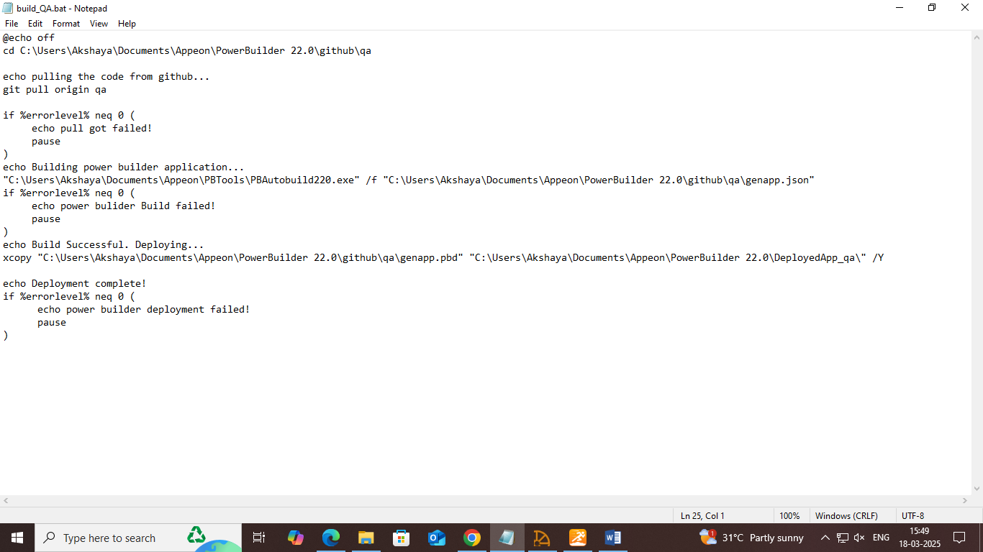

**Build and deploy the application automatically with the batch script**

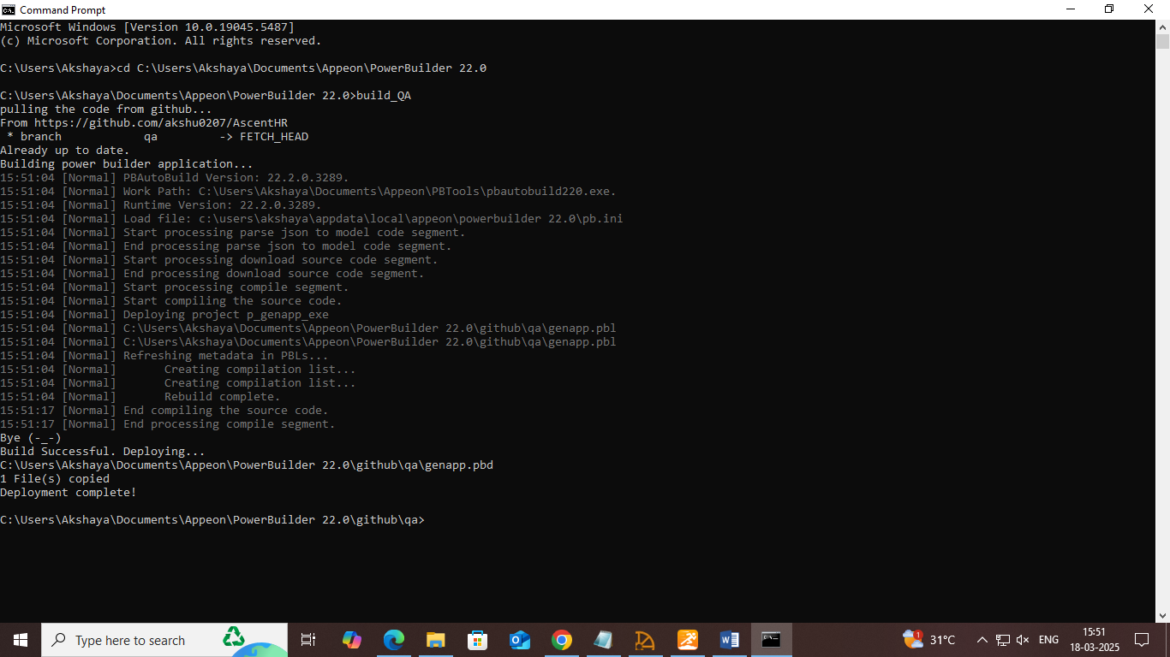

**Deployed app**

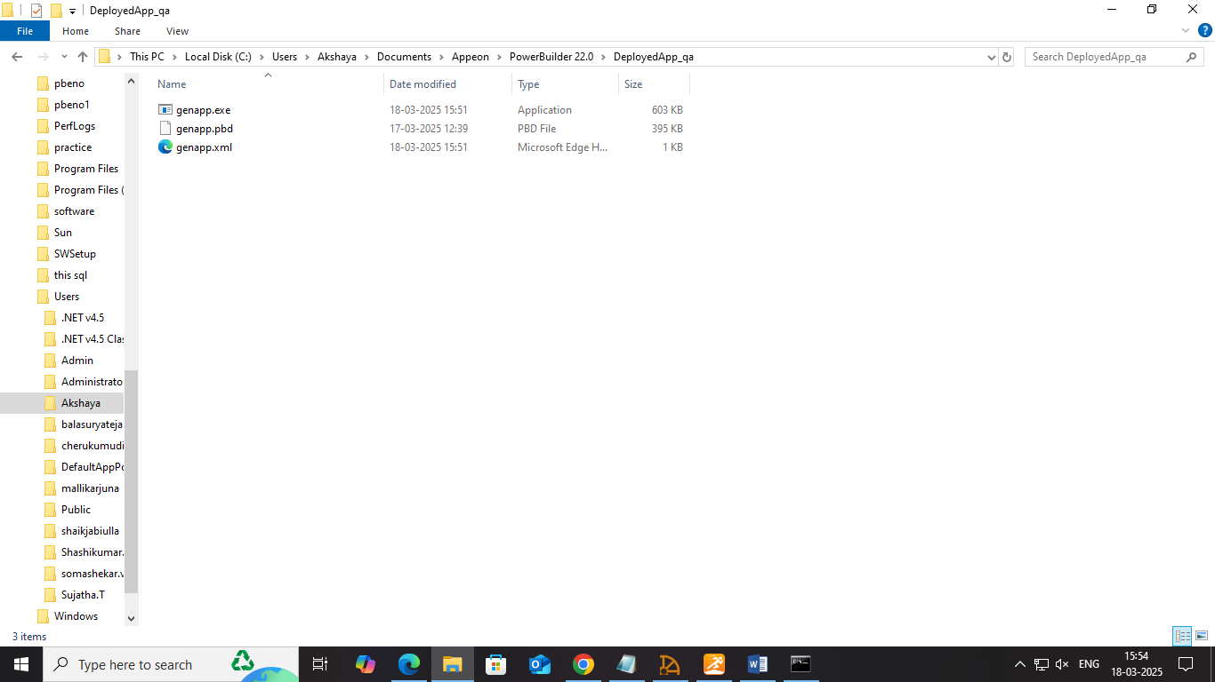

**Run the application to ensure new features are added**

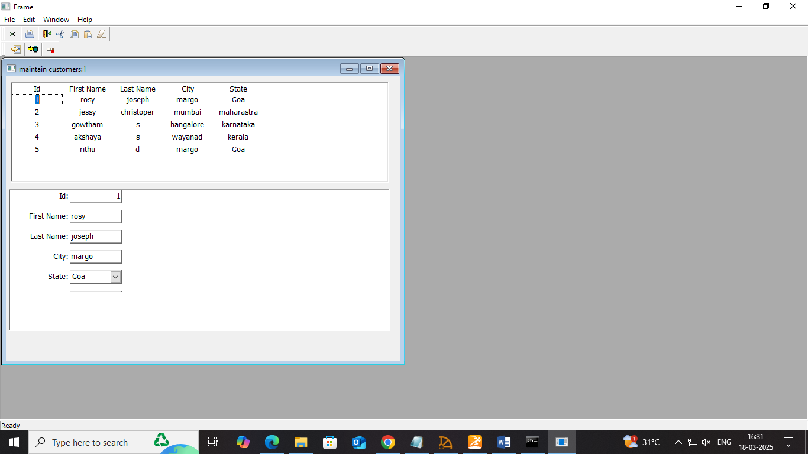

* **Once the QA branch works fine, switch to production:**
* Merge it with the production branch and test the application with build script by pulling from the production branch.

**Merge it with production branch using git:**

**Switching the branch $git checkout production or right click on the workspace>switch**

**$git merge qa**

* **Check production branch**
* 

**Change the path of the Executable file in json to deploy the application in a different folder called DeployedApp_production**

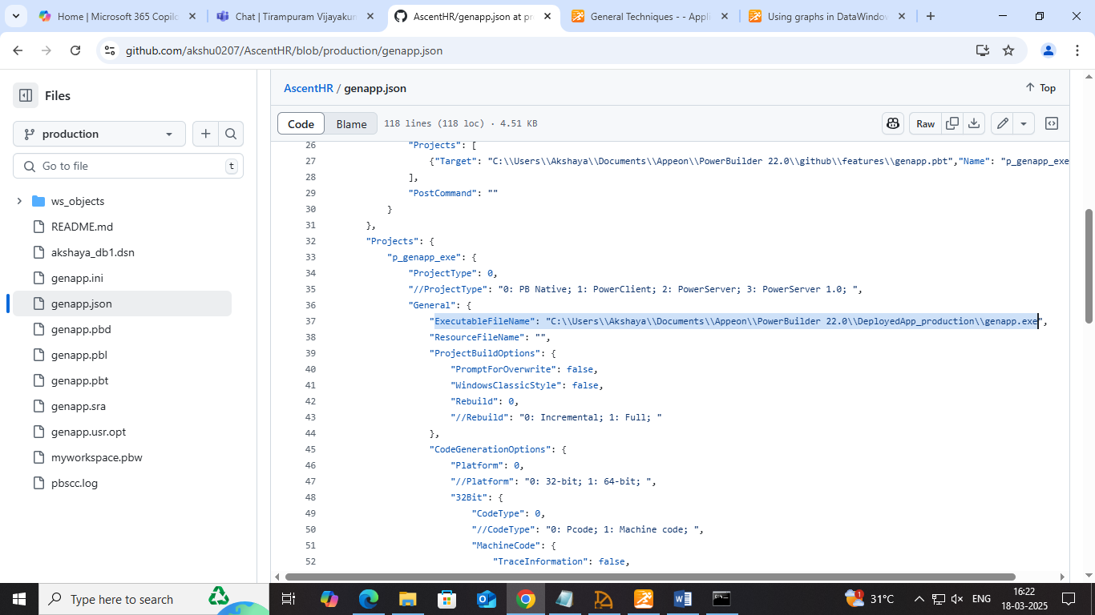

**Complete json:**

**﻿{**

**"MetaInfo": {**

**"IDEVersion": "220",**

**"RuntimeVersion": "22.2.0.3289"**

**},**

**"BuildPlan": {**

**"SourceControl": {**

**"PreCommand": "",**

**"ClearSrcBeforeDownload": false,**

**"SVN": [**

**{"SrcPath": "","User": "","Password": "","DestPath": "","Proxy": {"Ip": "","Port": 0,"Username": "","Password": ""}}**

**],**

**"Git": [**

**{"SrcPath": "","User": "","Password": "","DestPath": "","Branch": "","Proxy": {"Ip": "","Port": 0,"Username": "","Password": ""}}**

**],**

**"VSS": [**

**{"SrcPath": "","User": "","Password": "","DestPath": ""}**

**],**

**"Merging": [**

**{"Target": "","LocalProjectPath": "","RefreshPbl": true}**

**],**

**"PostCommand": ""**

**},**

**"BuildJob": {**

**"PreCommand": "",**

**"Projects": [**

**{"Target": "C:\\Users\\Akshaya\\Documents\\Appeon\\PowerBuilder 22.0\\github\\features\\genapp.pbt","Name": "p_genapp_exe"}**

**],**

**"PostCommand": ""**

**}**

**},**

**"Projects": {**

**"p_genapp_exe": {**

**"ProjectType": 0,**

**"//ProjectType": "0: PB Native; 1: PowerClient; 2: PowerServer; 3: PowerServer 1.0; ",**

**"General": {**

**"ExecutableFileName": "C:\\Users\\Akshaya\\Documents\\Appeon\\PowerBuilder 22.0\\DeployedApp_production\\genapp.exe",**

**"ResourceFileName": "",**

**"ProjectBuildOptions": {**

**"PromptForOverwrite": false,**

**"WindowsClassicStyle": false,**

**"Rebuild": 0,**

**"//Rebuild": "0: Incremental; 1: Full; "**

**},**

**"CodeGenerationOptions": {**

**"Platform": 0,**

**"//Platform": "0: 32-bit; 1: 64-bit; ",**

**"32Bit": {**

**"CodeType": 0,**

**"//CodeType": "0: Pcode; 1: Machine code; ",**

**"MachineCode": {**

**"TraceInformation": false,**

**"ErrorContextInformation": false,**

**"Optimization": 0,**

**"//Optimization": "0: Speed; 1: Space; 2: None; "**

**}**

**},**

**"64Bit": {**

**"CodeType": 0,**

**"//CodeType": "0: Pcode; "**

**},**

**"EnableDebugSymbol": true**

**}**

**},**

**"Libraries": [**

**{**

**"Library": "genapp.pbl",**

**"GeneralPBD": false,**

**"PBRFileName": ""**

**},**

**{**

**"Library": "genapp.pbl",**

**"GeneralPBD": false,**

**"PBRFileName": ""**

**}**

**],**

**"Version": {**

**"PropertiesDisplayedForExecutable": {**

**"ProductName": "PowerBuilder Enterprise Series",**

**"CompanyName": "Appeon",**

**"Description": "Appeon Product File",**

**"Copyright": "",**

**"ProductVersion": "1.0.0.1",**

**"FileVersion": "1.0.0.1"**

**},**

**"ExecutableVersionUsedByInstaller": {**

**"ProductVersion": [**

**1,**

**0,**

**0,**

**1**

**],**

**"FileVersion": [**

**1,**

**0,**

**0,**

**1**

**]**

**}**

**},**

**"Security": {**

**"ManifestInformation": {**

**"GenerateOptions": 0,**

**"//GenerateOptions": "0: No manifest; 1: Embedded Manifest; 2: External manifest; ",**

**"ExecutionLevel": 0,**

**"//ExecutionLevel": "0: As Invoker; 1: Highest Available; 2: Require Administrator; ",**

**"AllowAccessToProtectedSystemUI": false**

**}**

**},**

**"Run": {**

**"Application": "C:\\Users\\Akshaya\\Documents\\Appeon\\PowerBuilder 22.0\\github\\production\\genapp.exe",**

**"Arguments": "",**

**"StartIn": "",**

**"RuntimePathInApplicationXML": ""**

**}**

**}**

**}**

**}**

* **Commit the changes and push:** right click on the workspace>git commit>git push

**Batch script for production branch**

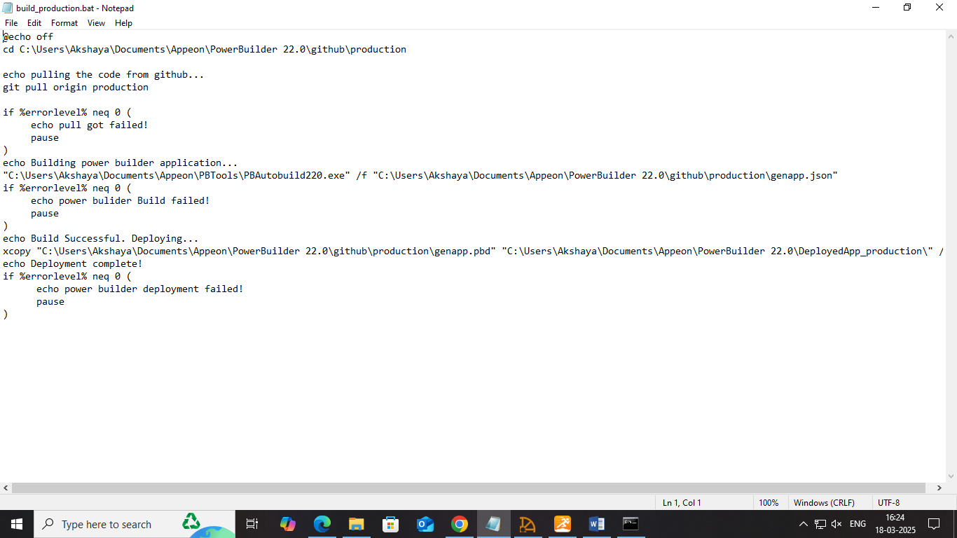

**Build and deploy the application automatically with the batch script**

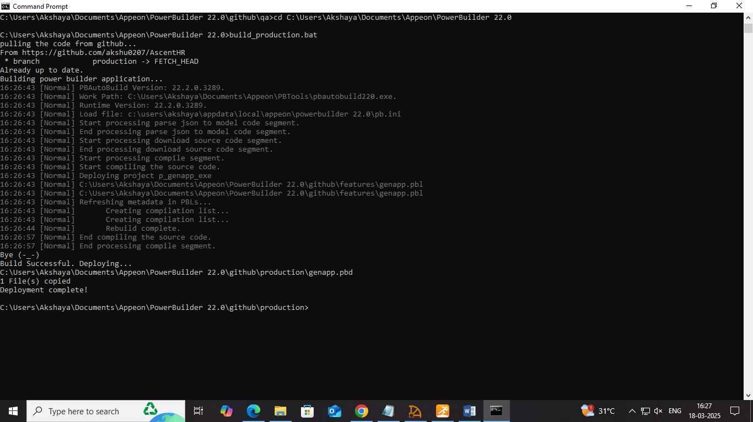

**Deployed app**

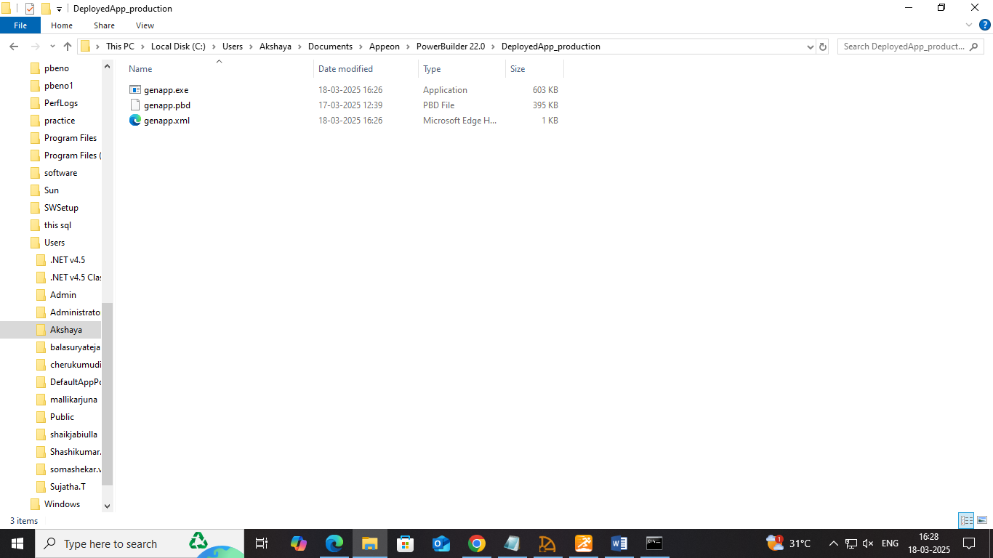

**Run the application**

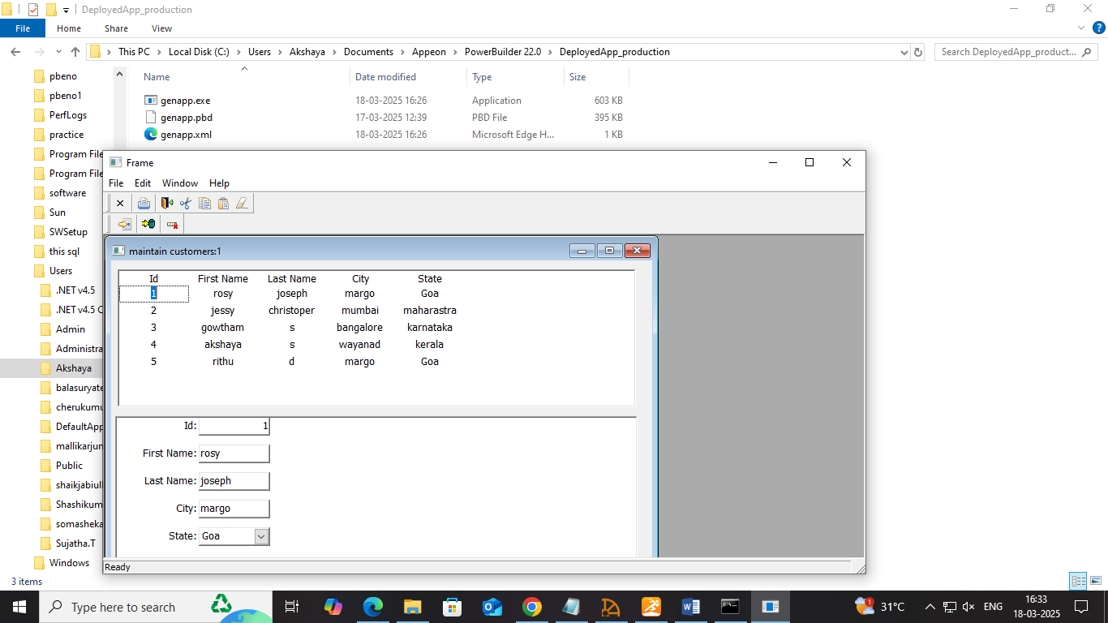

* Once everything is works as intended, merge it with master/main branch.

**Merge it with master branch using git:**

**Switching the branch: $git checkout master or right click on the workspace>switch**

**$git merge production**

* **Check master branch in github**

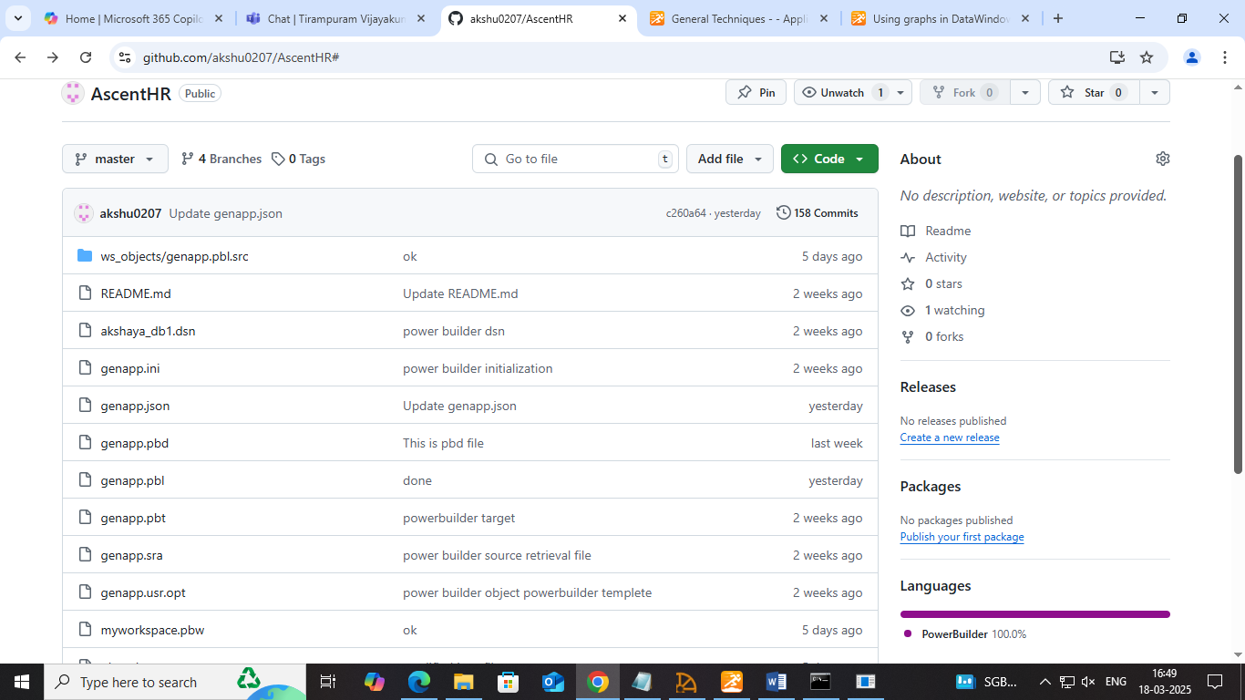

* By integrating Git with PowerBuilder, developers can track changes, collaborate efficiently, and maintain a structured version history while automating the build and deployment process. Right click on the workspace to create the necessary branches.

This method helps keep the local workspace synchronized with the GitHub repository, minimizing conflicts and ensuring all changes are up to date. In this project, PowerBuilder's Source Control feature is used to connect to Git for version management.